**Create Event Flow**

Select Manage Events

Click Create Event Menu Item

Register/Login

Login Failed

Fill Out Event Form/s

Review Event

Confirm/Complete

Logout

**Update Event/s Flow**

Select Manage Events

Click Update Events

Menu Item

Register/Login

Login Failed

View/Manage Events

Review Event/s

Confirm/Complete

Logout

**Delete Event**

Select Manage Events

Select Delete event/s menu item

Register/Login

Login Failed

View/Manage Events

Select event/s

Confirm/Complete

Logout

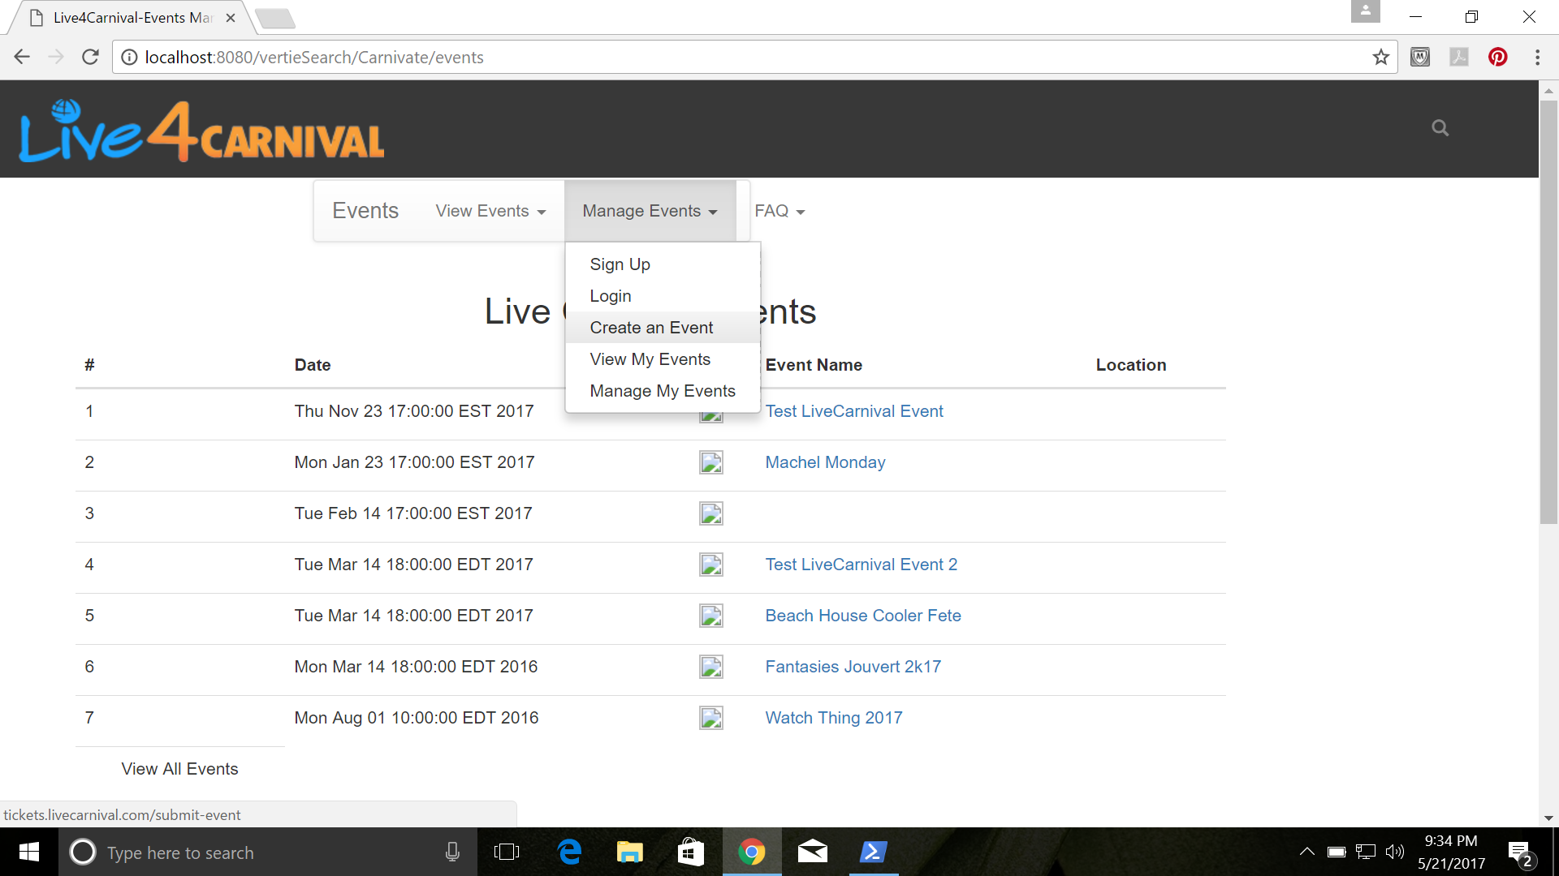

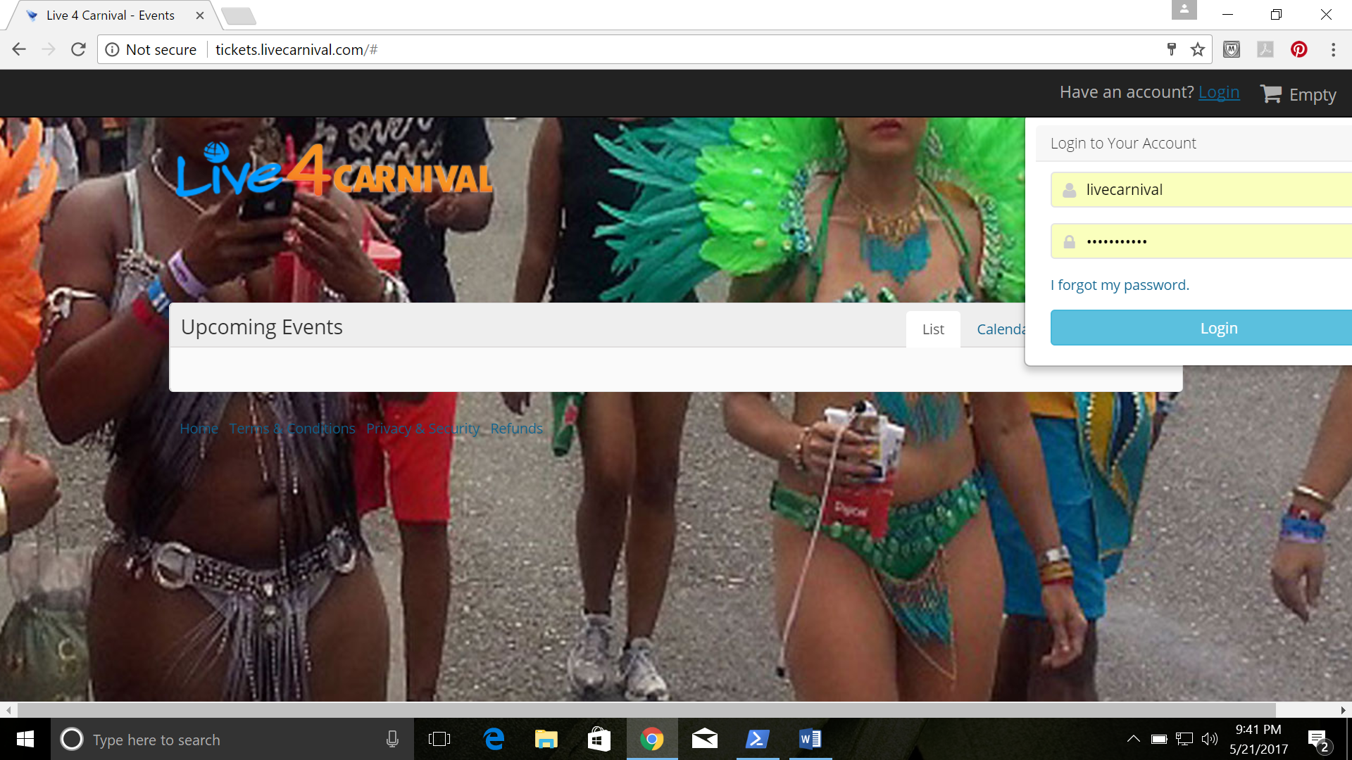

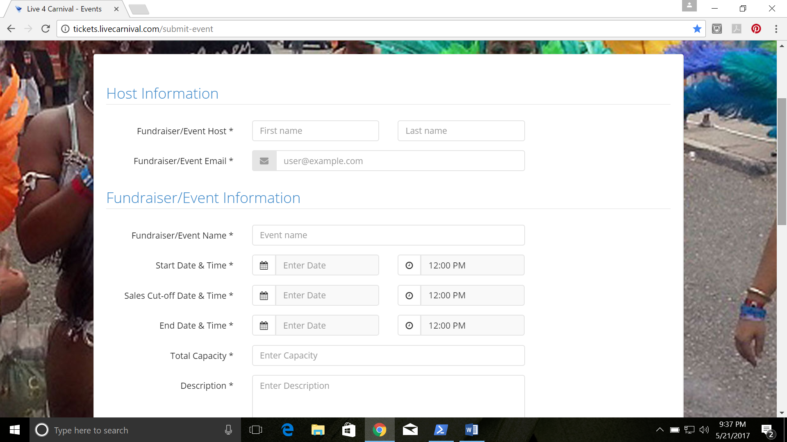

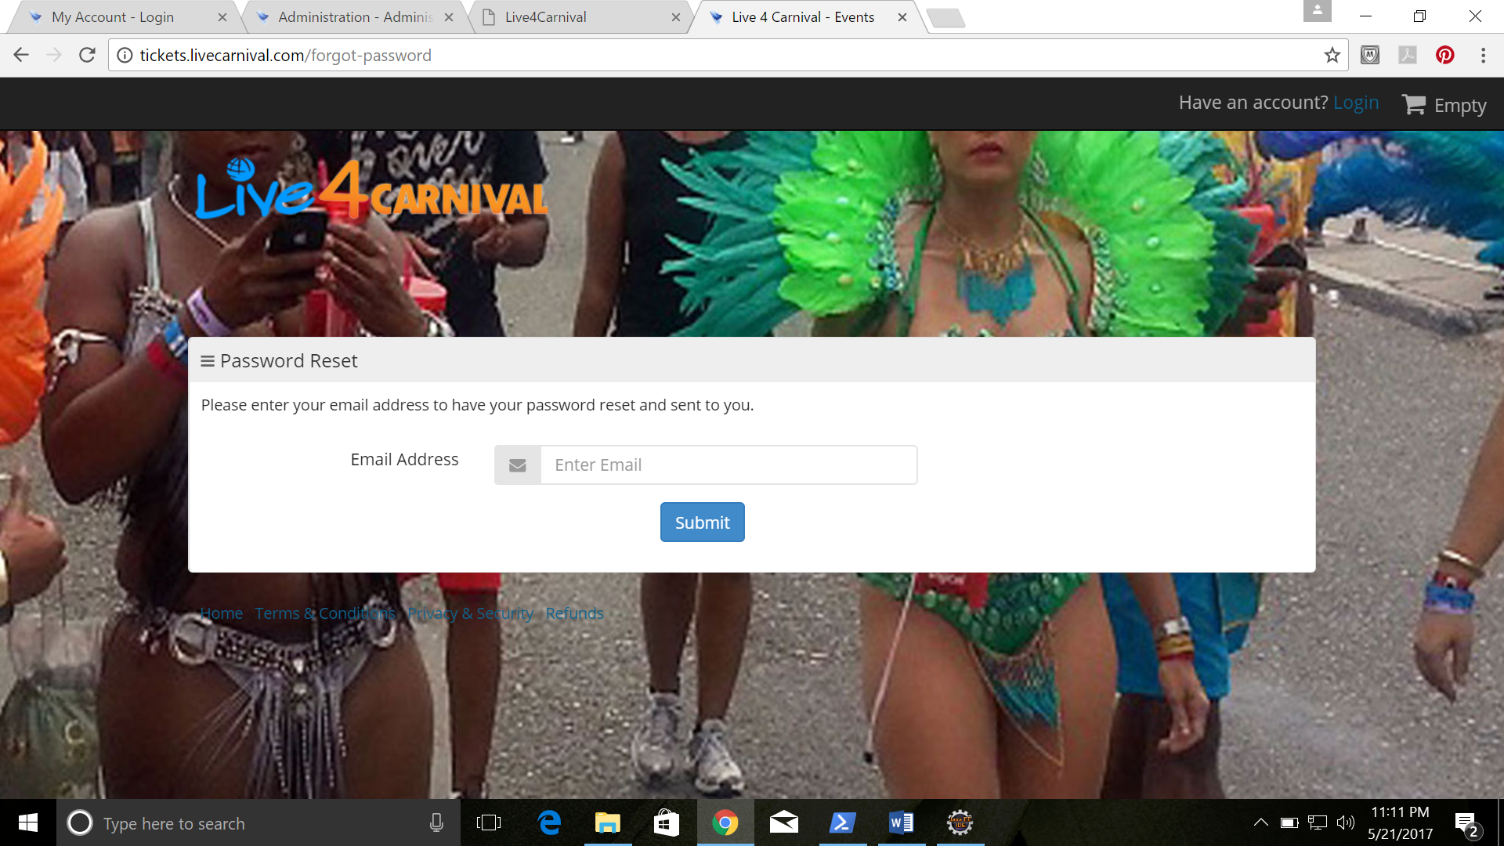

Do we need a Sign Up page/form or is there already one? This is for signing up to use our ticketing product. We might have that, need to verify and get the link from Arnim.

1. When someone signs up how do we create their account? Yes
2. How do we ensure that view for users is different than our admin view? We need to verify.
3. Terms of agreement needs to be added to either both the sign up form and or upon review of creating an event. Need to edit it.
4. We need content for the Events FAQ.